1. **package** cse;

**import** java.util.*;

**import** java.util.Scanner.*;

**public** **class** PosNegZero {

**public** **static** **void** main(String[] args) {

{

**int** n;

Scanner sc=**new** Scanner(System.***in***);

System. ***out***. print("Enter the number you want to check:");

n=sc. nextInt();

**if**(n>0) {

System. ***out***. println ("The given number is "+n+" is positive");

}

**else** **if**(n<0) {

System. ***out***. println ("The given number is "+n+" is negative");

}

**else**

{

System. ***out***. println ("The given number is"+n+" neither positive nor negative");

}

}

}

}

**OUTPUT:**

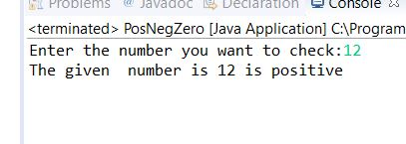

2. **package** cse;

**import** java.util.*;

**import** java.util.Scanner.*;

**public** **class** GreatestNumber {

**public** **static** **void** main(String[] args) {

Scanner sc=**new** Scanner(System.***in***);

**int** number1,number2;

number1=sc.nextInt();

number2=sc.nextInt();

**if**(number1>number2)

{

System.***out***.println(number1 +"is greater");

}

**else**

{

System.***out***.println( number2 +"is greater");

}

}

}

OUTPUT:

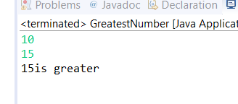

3. **package** cse;

**import** java.util.*;

**import** java.util.Scanner.*;

**public** **class** EvenOdd {

**public** **static** **void** main(String[] args) {

Scanner sc=**new** Scanner(System.***in***);

System.***out***.print("Enter a number:");

**int** num=sc.nextInt();

**if**(num%2==0)

{

System.***out***.println(num +"is even");

}

**else**

{

System.***out***.println(num +"is odd");

}

}

}

OUTPUT:

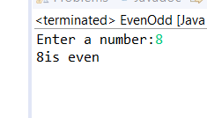

4. **package** cse;

**import** java.util.*;

**import** java.util.Scanner.*;

**public** **class** GreatestNumber {

**public** **static** **void** main(String[] args) {

Scanner sc=**new** Scanner(System.***in***);

**int** number1,number2;

number1=sc.nextInt();

number2=sc.nextInt();

**if**(number1>number2)

{

System.***out***.println(number1 +"is Even");

}

**else**

{

System.***out***.println( number2 +"is Odd");

}

}

}

OUTPUT:

